Peixin Yao(001526352)

**Program Structures & Algorithms**

**Fall 2021**

**Assignment No. 5**

* **Task (List down the tasks performed in the Assignment)**

Step 1:  
A cutoff (defaults to, say, 1000) which you will update according to the first argument in the command line when running. It's your job to experiment and come up with a good value for this cutoff. If there are fewer elements to sort than the cutoff, then you should use the system sort instead.

Step 2:  
Recursion depth or the number of available threads. Using this determination, you might decide on an ideal number (*t*) of separate threads (stick to powers of 2) and arrange for that number of partitions to be parallelized (by preventing recursion after the depth of *lg t* is reached).

Step 3:  
An appropriate combination of these.

* **Relationship Conclusion: (For ex : z = a * b)**

(cutoff:Good value of cutoff,size:array.size,threads:number of threads available)

Conclusion1:cutoff=size/threads;

Conclusion2:for my computer(macbook pro 2019 i9),When 4<=threads<=64, the efficacy of this method is good.

* **Evidence to support the conclusion:**

1. **Output (Snapshot of Code output in the terminal)**

**Size=1000000 threads=2 cutoff=500000**

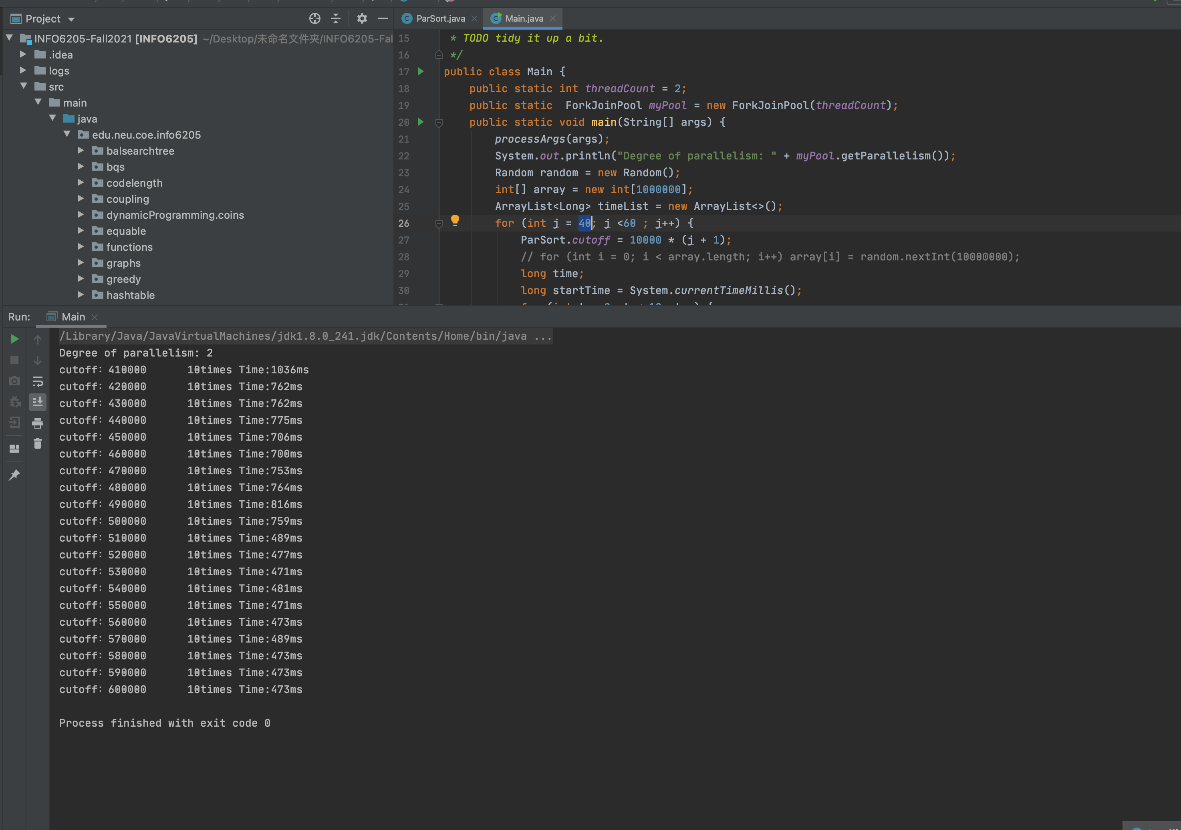

**Size=1000000 threads=4 cutoff=250000**

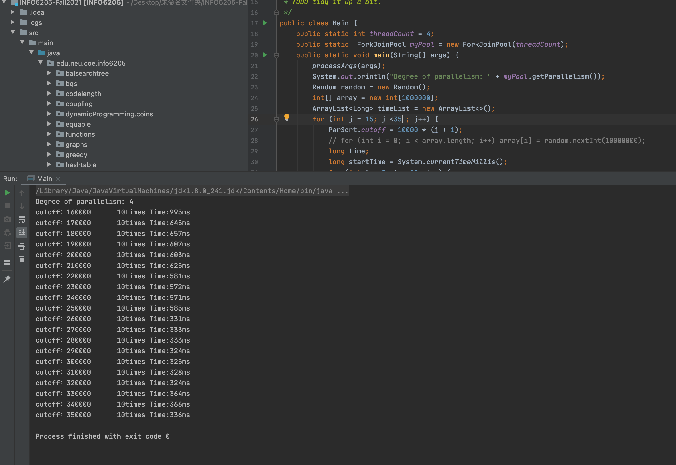

**Size=1000000 threads=8 cutoff=125000**

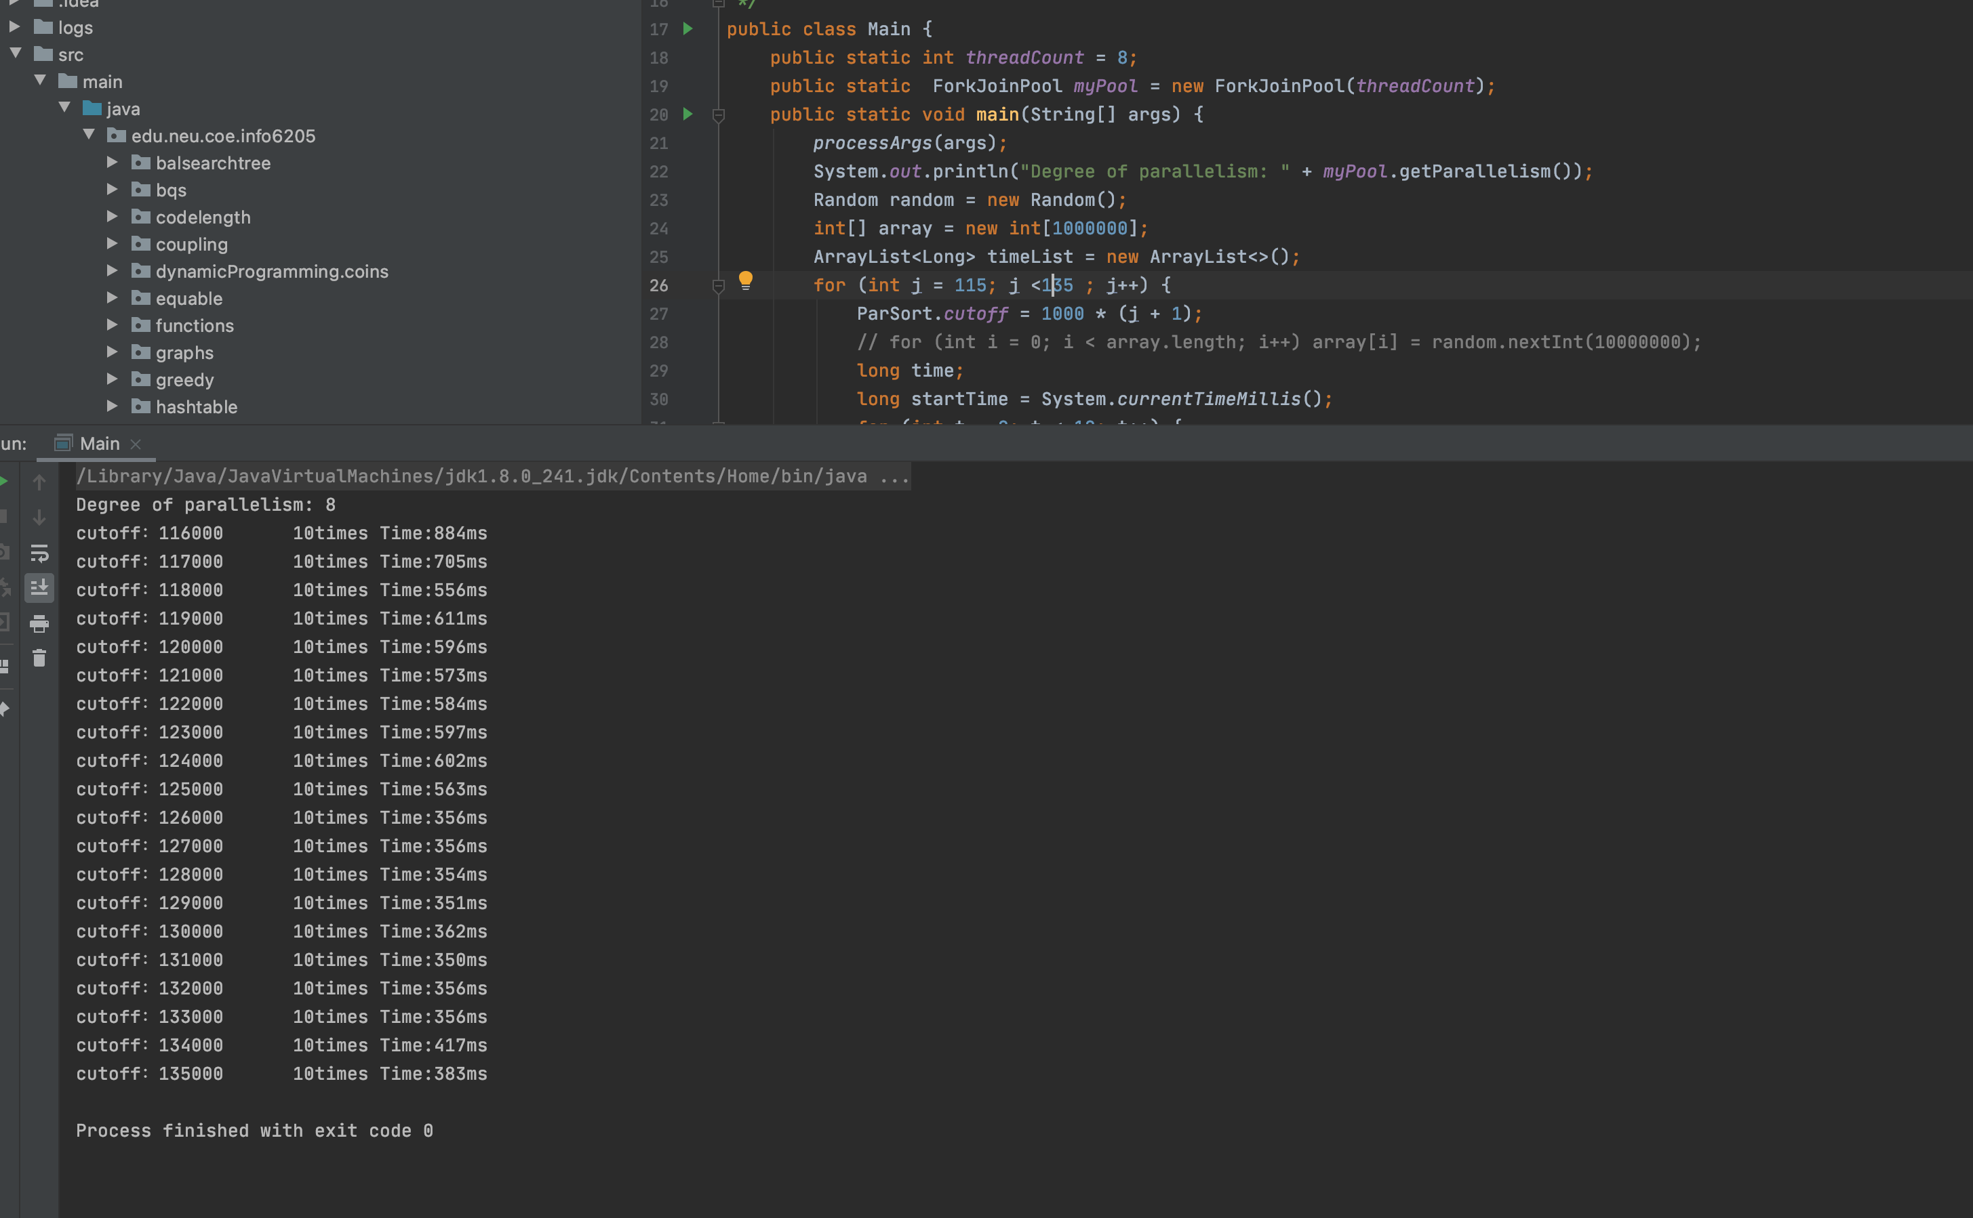

**Size=2000000 threads=2 cutoff=1000000**

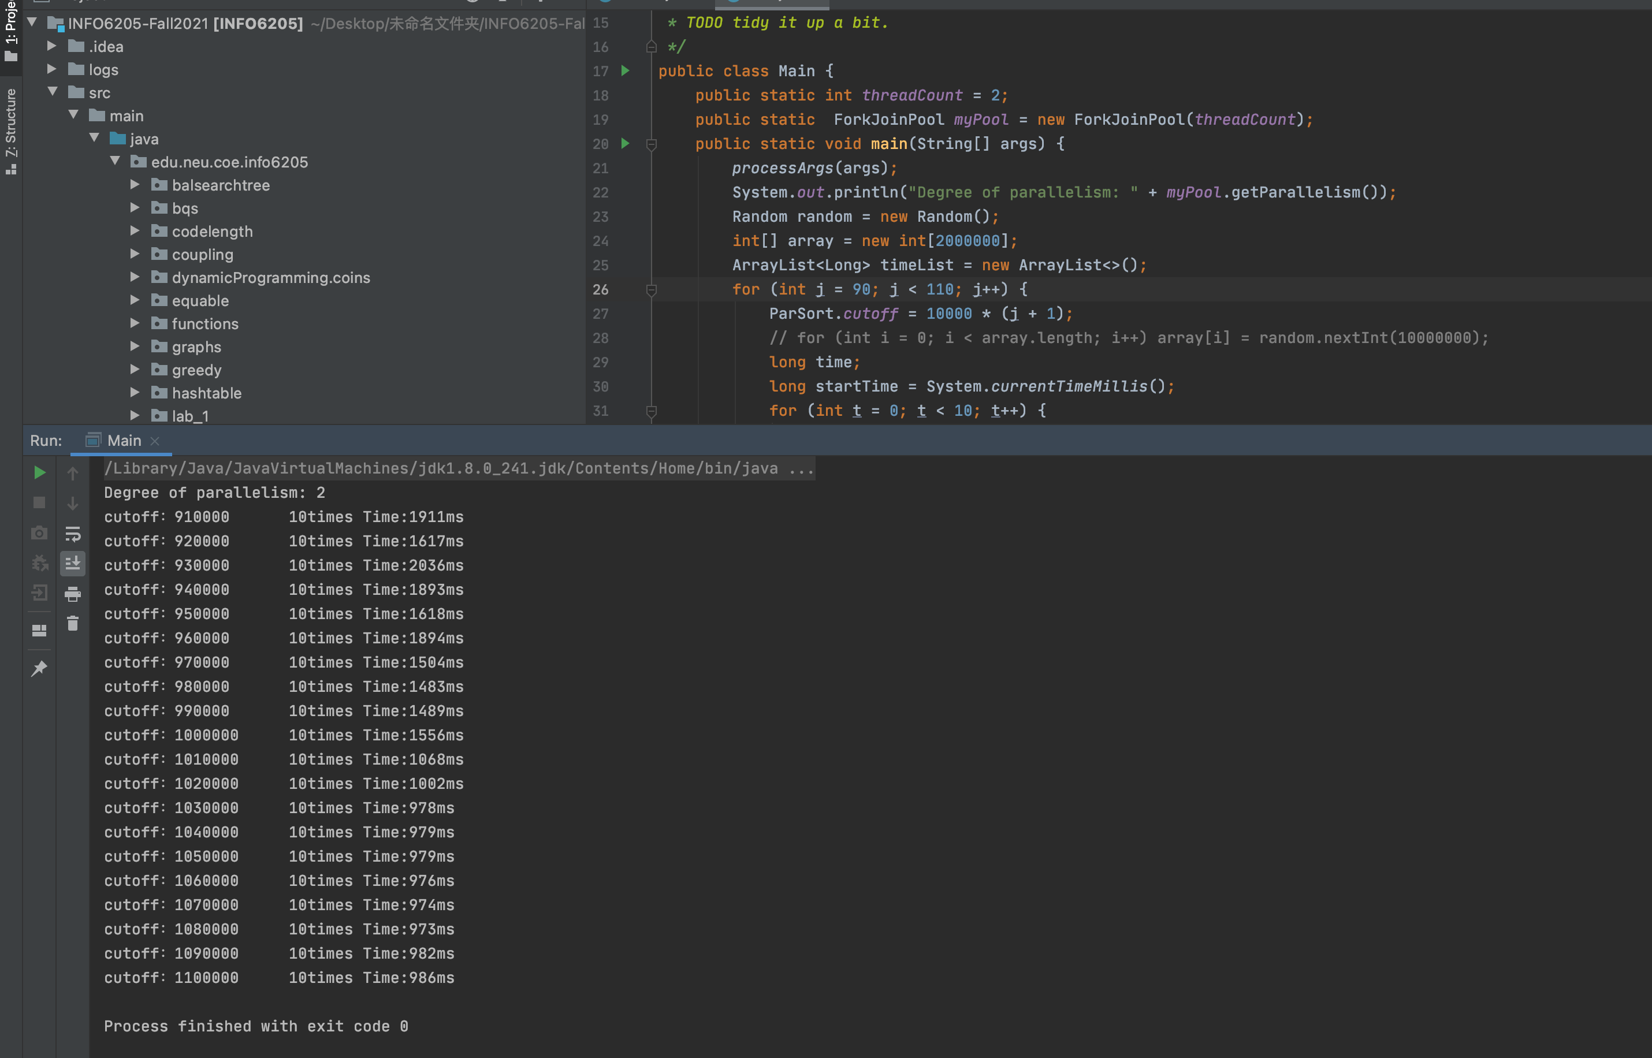

**Size=2000000 threads=4 cutoff=500000**

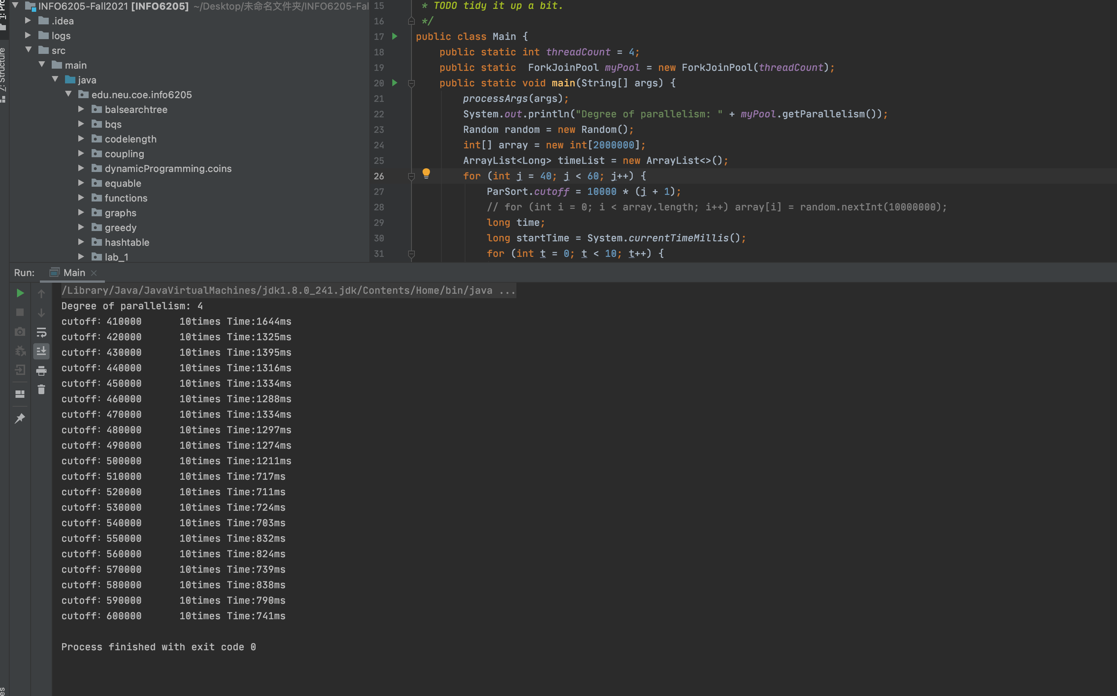

**Size=2000000 threads=8 cutoff=250000**

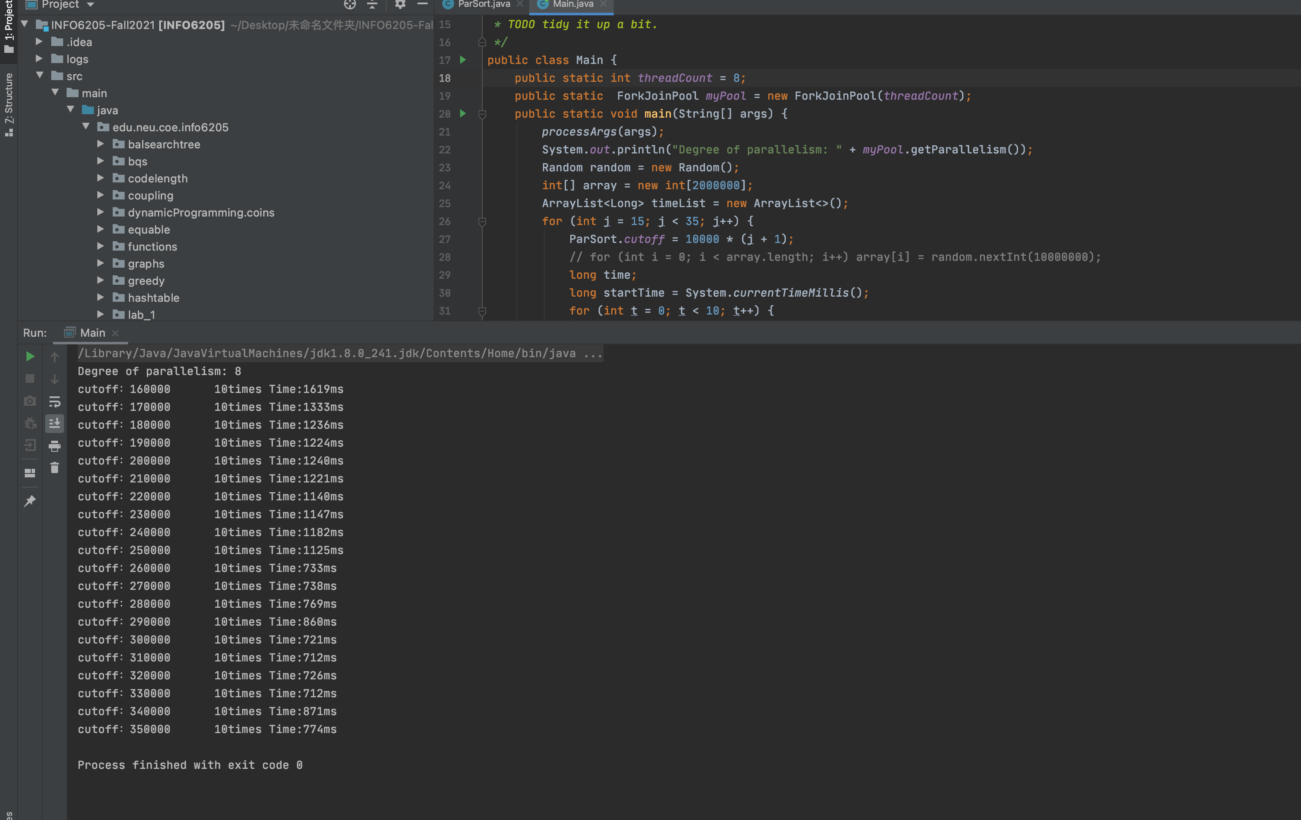

**Size=2000000 threads=16 cutoff=125000**

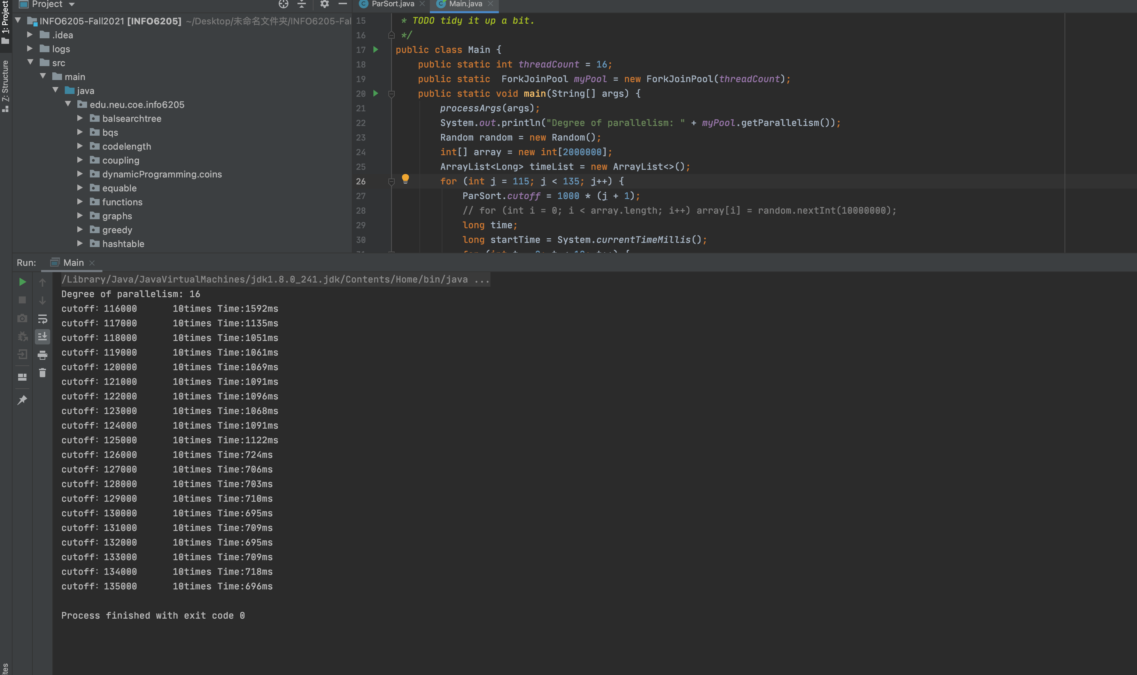

**Size=2000000 threads=32 cutoff=62500**

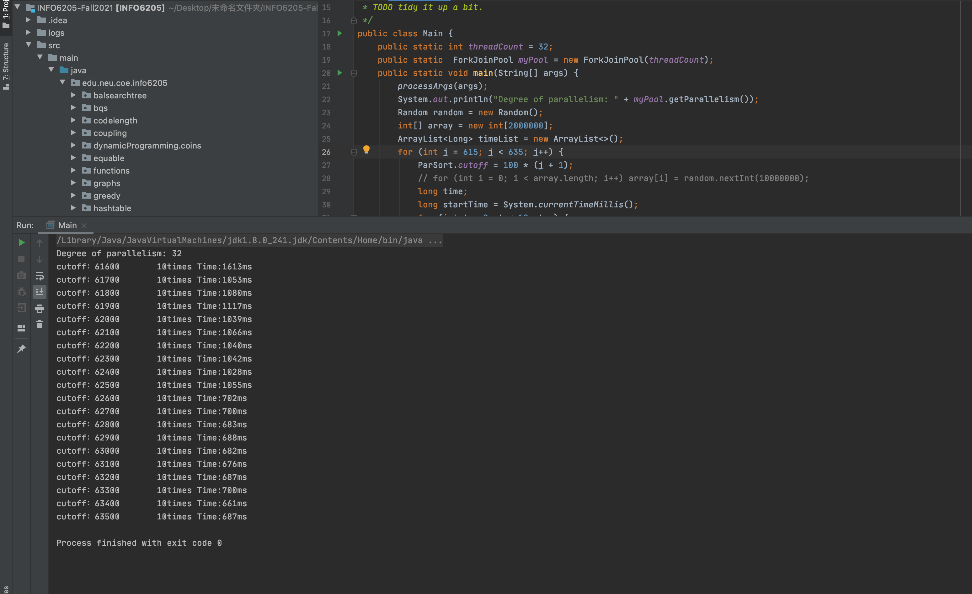

**Size=2000000 threads=64 cutoff=31250**

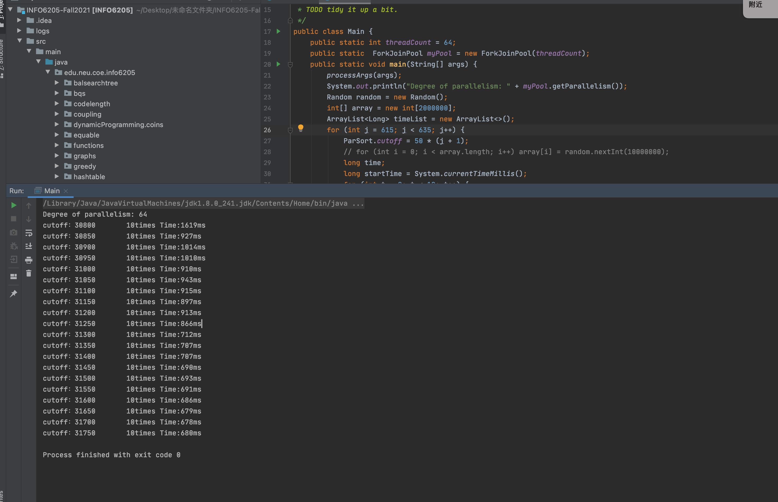

**Size=2000000 threads=128 cutoff=15625**

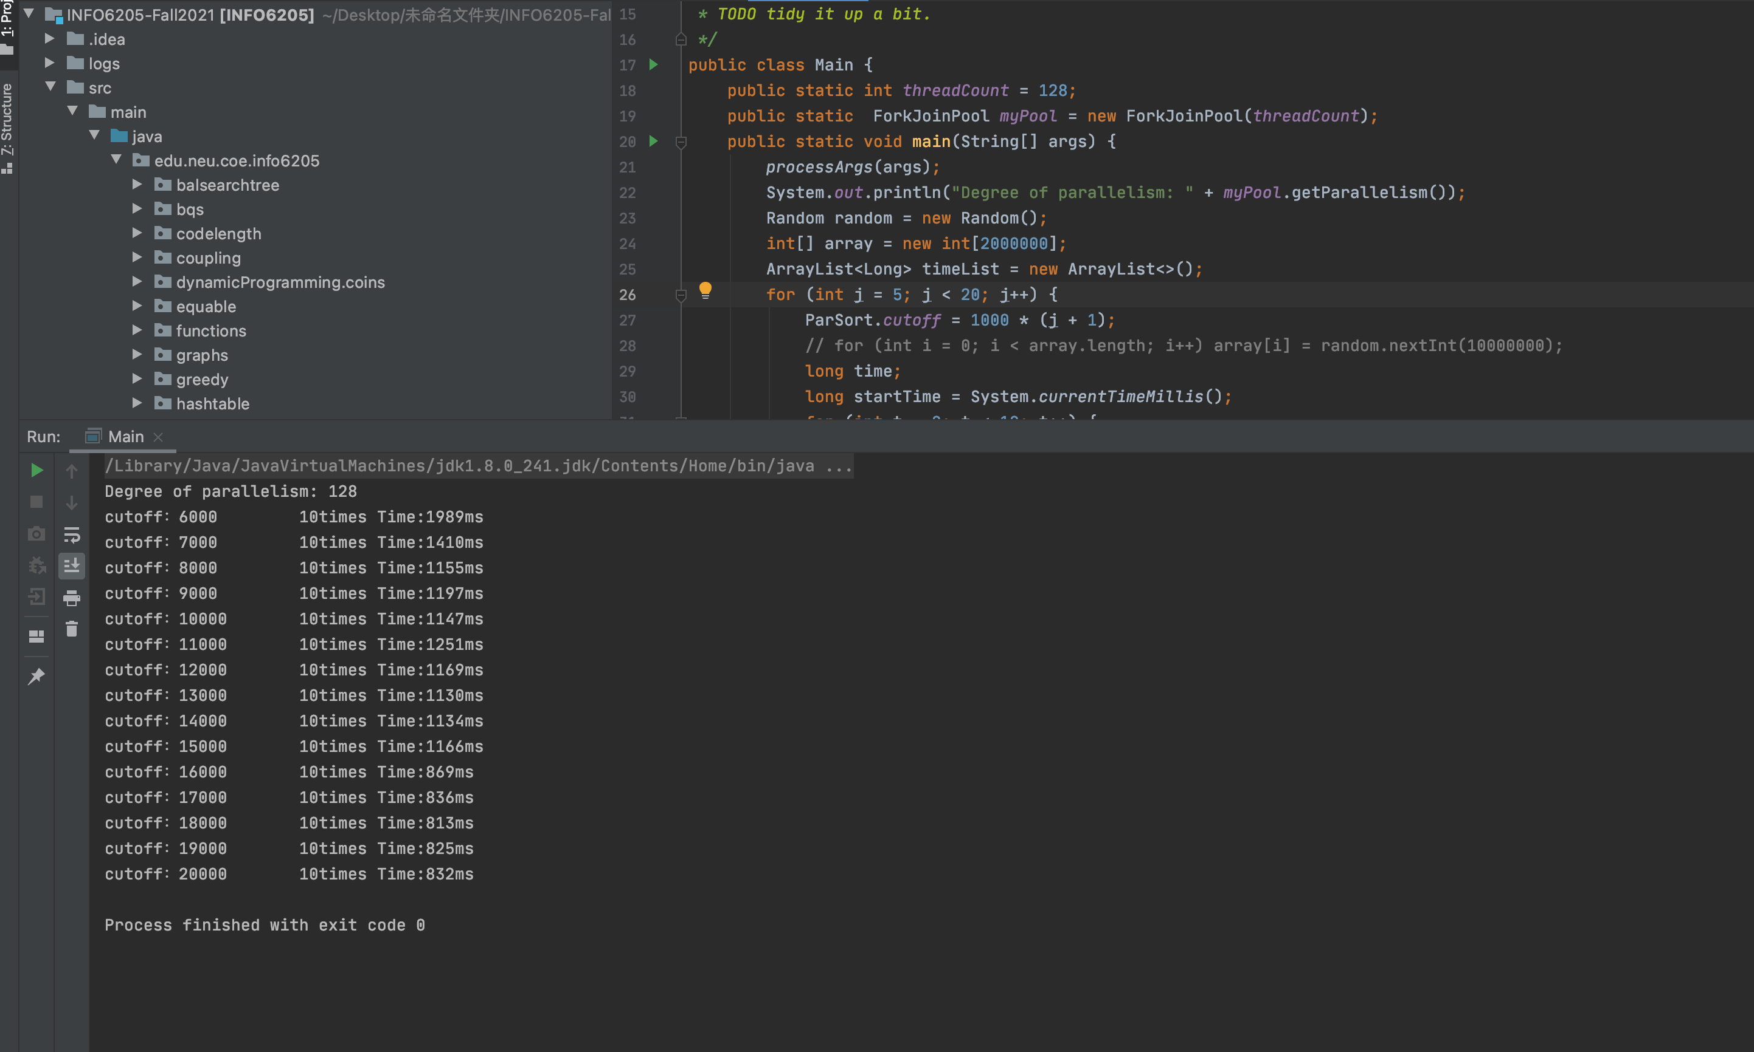

**Size=4000000 threads=2 cutoff=2000000**

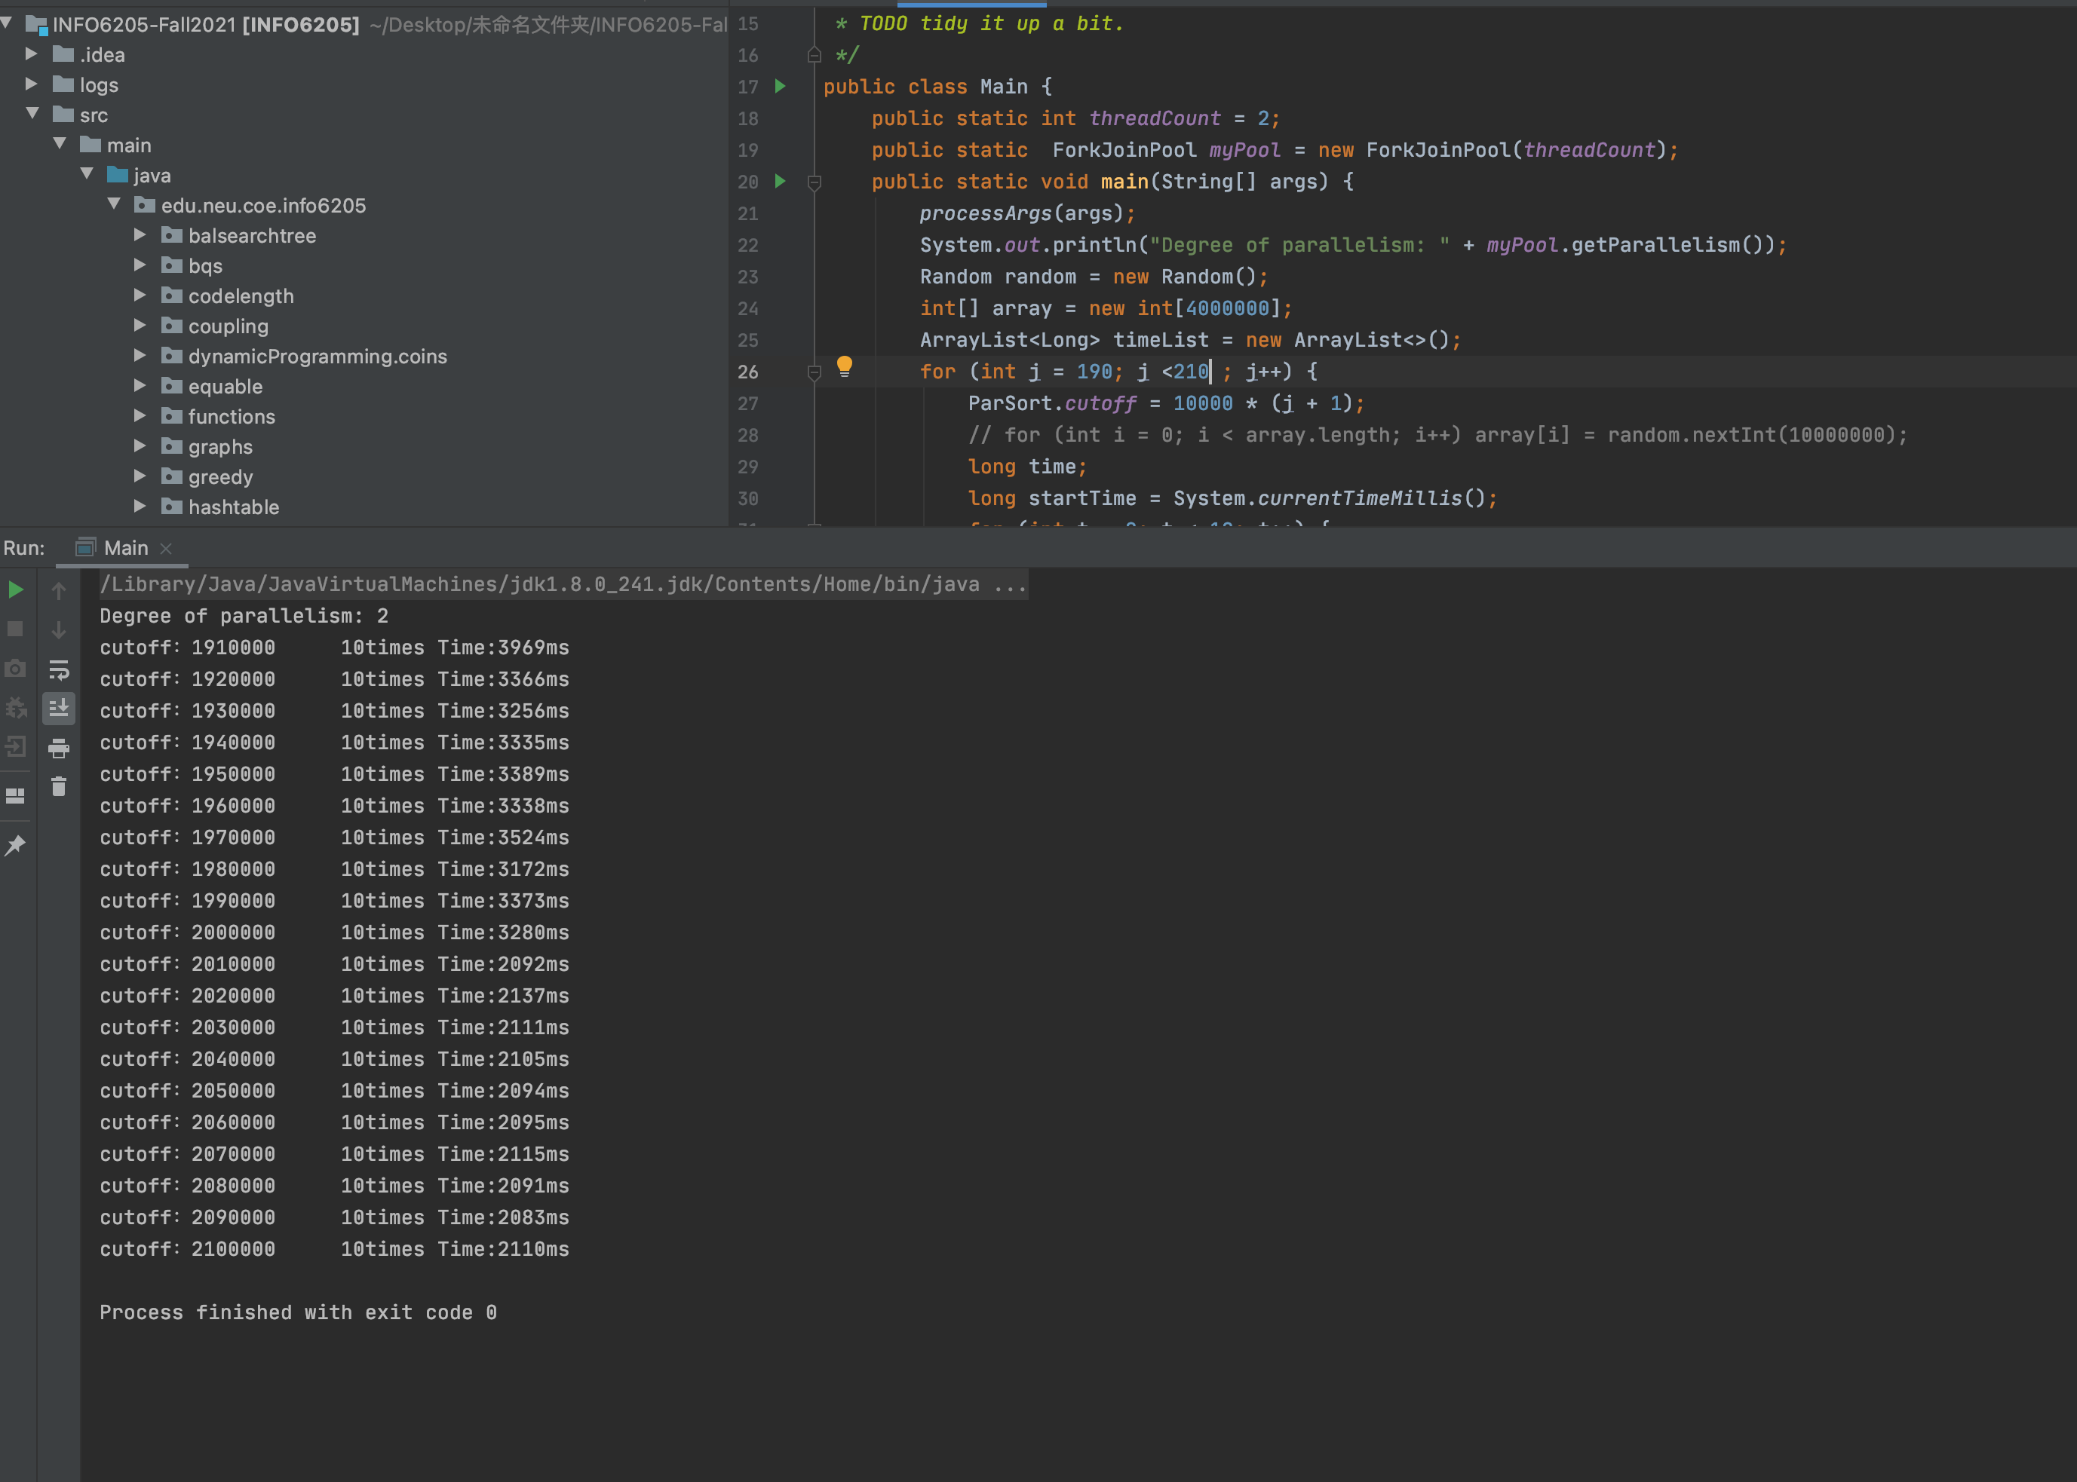

**Size=4000000 threads=4 cutoff=1000000**

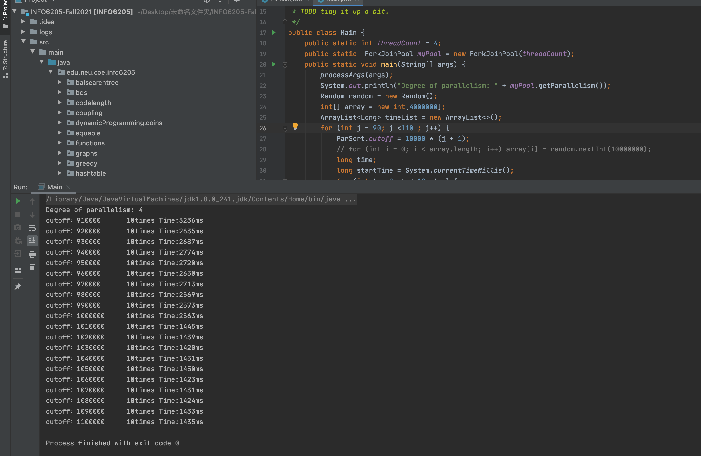

**Size=4000000 threads=8 cutoff=500000**

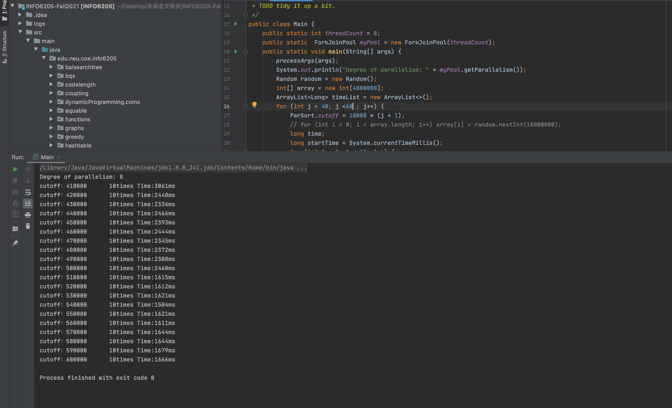

**Size=8000000 threads=4 cutoff=2000000**

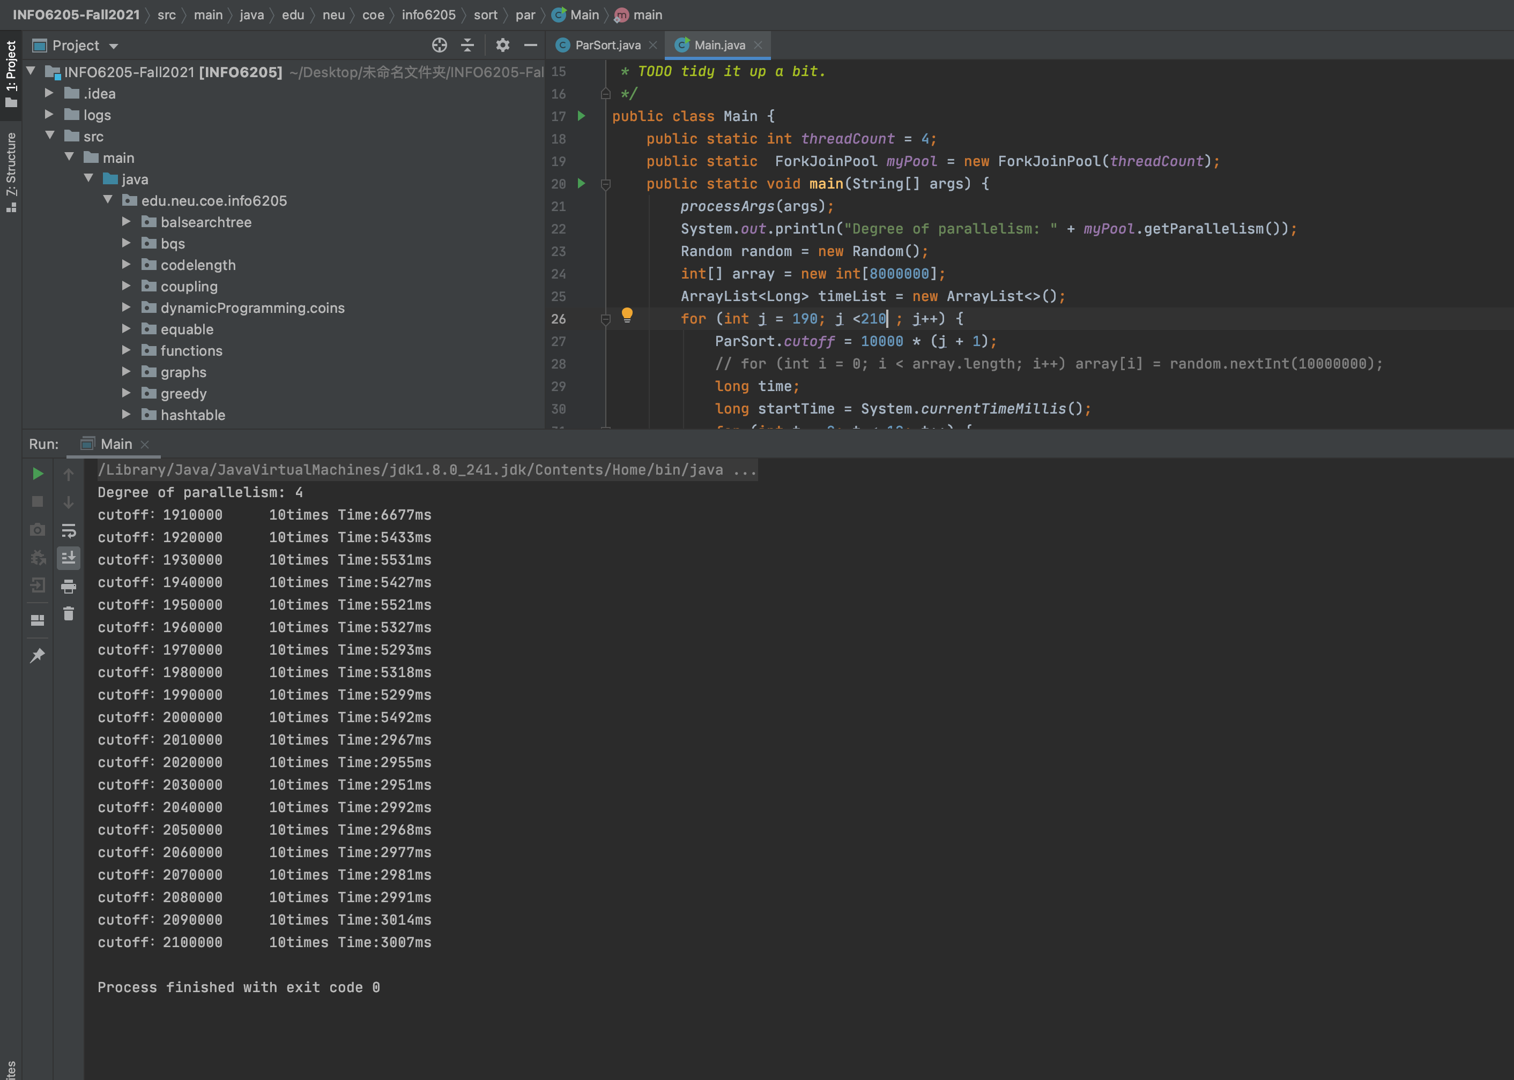

**Size=8000000 threads=8 cutoff=1000000**

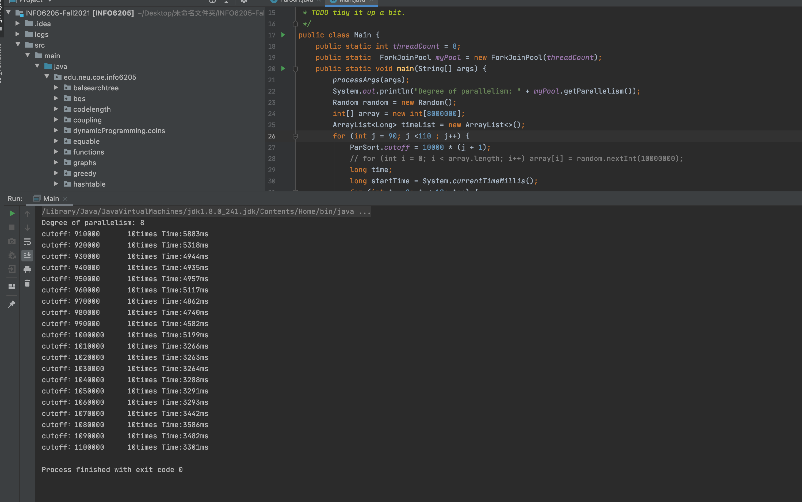

1. **Graphical Representation(Observations from experiments should be tabulated and analyzed by plotting graphs(usually in excel) to arrive on the relationship conclusion)**

**When threads is determined,cutoff=array.size/threads**

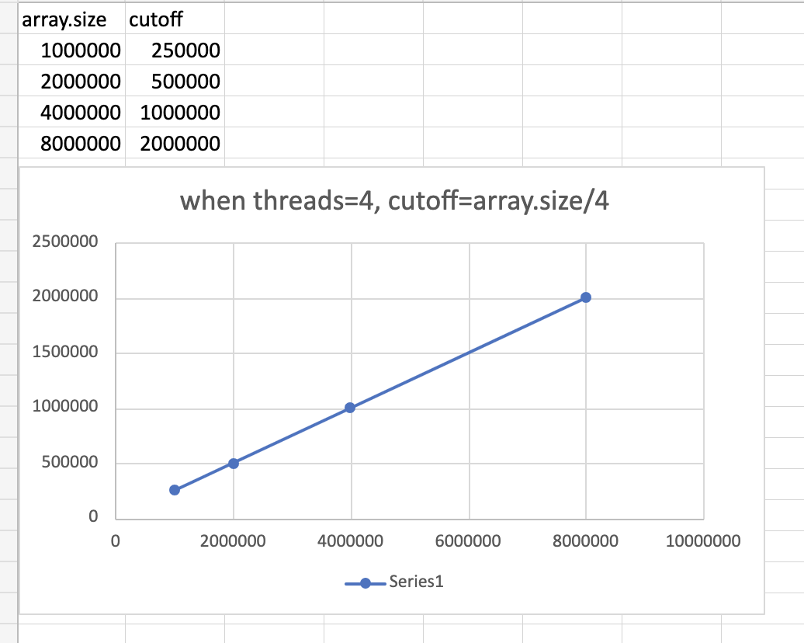

**When array.size is determined,cut off=array.size/threads**

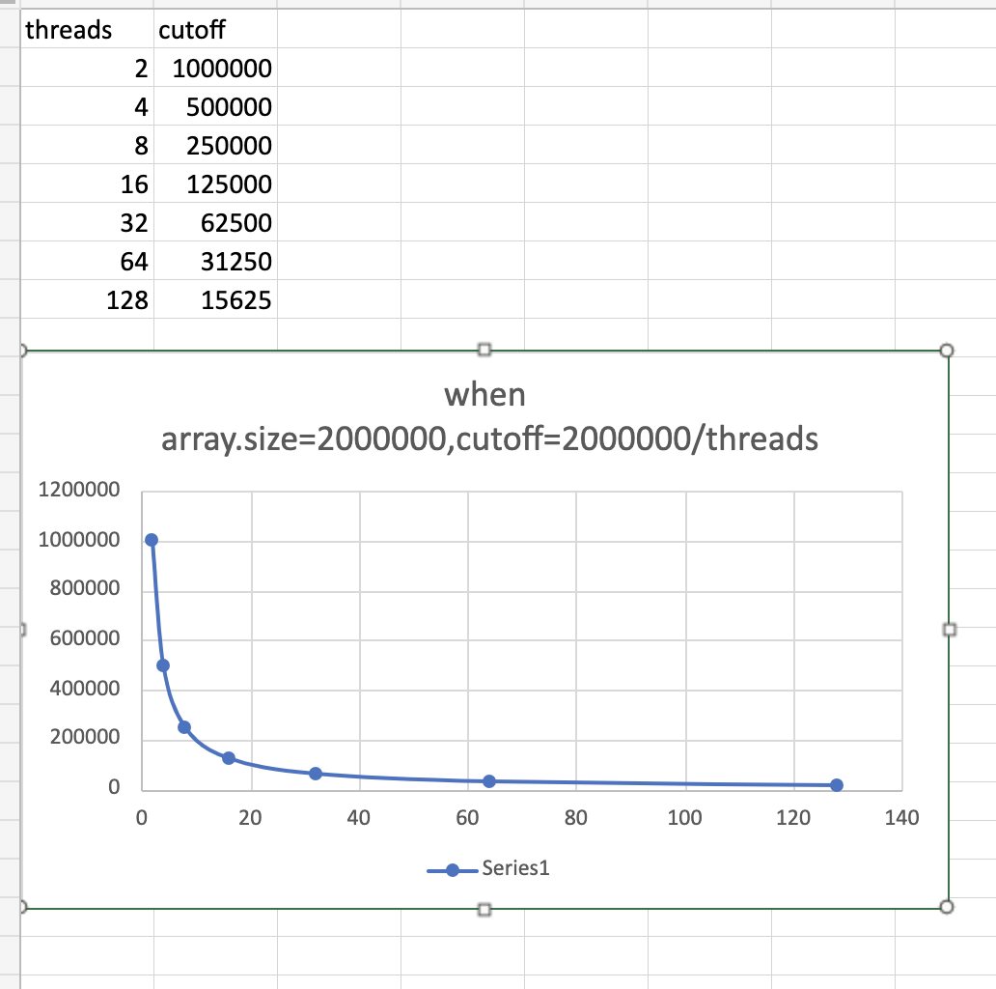

**Array.size=2000000,cutoff is good value,when 4<=threads<=64, the efficacy(the time) is good.**

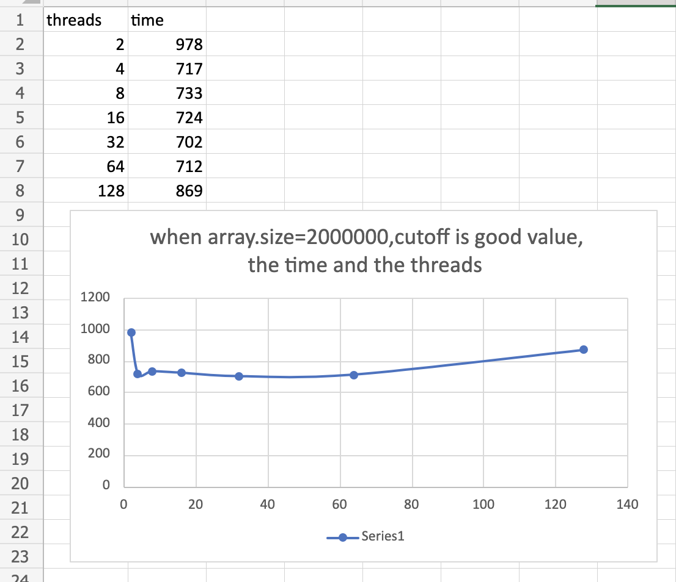

* **Unit tests result:(Snapshot of successful unit test run)**